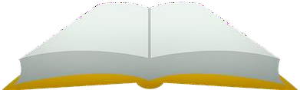

|  |  |  |
| --- | --- | --- |
|  | | |
| **8** | **6** | **7** |

|  |  |  |
| --- | --- | --- |
|  | | |
| **6** | **4** | **5** |

|  |  |  |
| --- | --- | --- |
|  | | |
| **8** | **7** | **5** |

|  |  |  |
| --- | --- | --- |
|  | | |
| **8** | **6** | **9** |



|  |  |  |
| --- | --- | --- |
|  | | |
| **6** | **9** | **5** |

|  |  |  |
| --- | --- | --- |
|  | | |
| **8** | **9** | **10** |

|  |  |  |
| --- | --- | --- |
|  | | |
| **3** | **4** | **5** |

|  |  |  |
| --- | --- | --- |
|  | | |
| **7** | **6** | **8** |





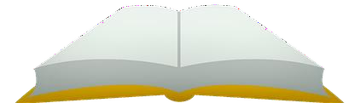

|  |  |  |
| --- | --- | --- |
|  | | |
| **7** | **8** | **9** |

|  |  |  |
| --- | --- | --- |
|  | | |
| **9** | **8** | **10** |

|  |  |  |
| --- | --- | --- |
|  | | |
| **6** | **5** | **7** |

|  |  |  |
| --- | --- | --- |
|  | | |
| **8** | **6** | **7** |







|  |  |  |
| --- | --- | --- |
|  | | |
| **9** | **10** | **8** |

|  |  |  |
| --- | --- | --- |
|  | | |
| **4** | **6** | **5** |

|  |  |  |
| --- | --- | --- |
|  | | |
| **4** | **6** | **5** |

|  |  |  |
| --- | --- | --- |
|  | | |
| **7** | **10** | **8** |



|  |  |  |
| --- | --- | --- |
|  | | |
| **3** | **4** | **2** |

|  |  |  |
| --- | --- | --- |
|  | | |
| **1** | **3** | **2** |

|  |  |  |
| --- | --- | --- |
|  | | |
| **3** | **4** | **2** |

|  |  |  |
| --- | --- | --- |
|  | | |
| **1** | **2** | **3** |





|  |  |  |
| --- | --- | --- |
|  | | |
| **2** | **1** | **3** |

|  |  |  |
| --- | --- | --- |
|  | | |
| **3** | **1** | **2** |

|  |  |  |
| --- | --- | --- |
|  | | |
| **3** | **2** | **1** |

|  |  |  |
| --- | --- | --- |
|  | | |
| **3** | **1** | **2** |

